A000-Afr-Egypt-Alexandria-Zeus Serapis-Bust-Bronze -1st century BCE

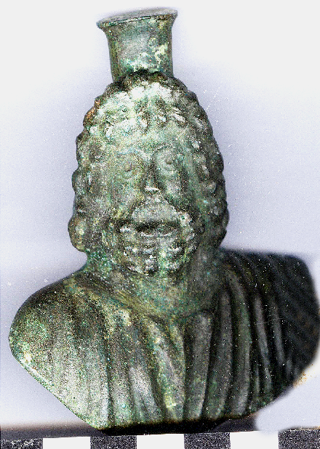 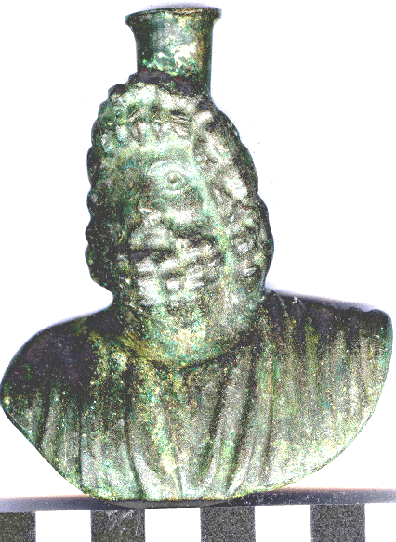

Figs. 1-2. Afr-Egypt-Alexandria-Zeus Serapis-Bust-Bronze -1st century BCE

Case no.:

Accession Number:

Formal Label: Afr-Egypt-Alexandria-Zeus Serapis-Bust-Bronze -1st century BCE

Display Description: This personal votive bust of Zeus Serapis was a favorite in Hellenistic Alexandria. Serapis was essentially a construct of the Ptolemaic Greek rulers of Egypt, a conflation of the local gods Osiris and Apis (Chubova, Kon'kova, Davydova 1986: 33; Alvar Ezquerra: 2008). In 391 AD/CE, Emperor Theodosius I officially ordered the destruction of the Serapeum, or Temple of Serapis at Alexandria to combat paganism. The destruction of the Serapeum was executed by Theophilus, Bishop of Alexandria, and a Christian church was built on the site in 391 AD/CE to cleanse it of any taint of Serapis (McKenzie, Gibson, Reyes 2004).

LC Classification: 2450.S4

Date or Time Horizon: 1st century BCE

Geographical Area: Alexandria, Egypt

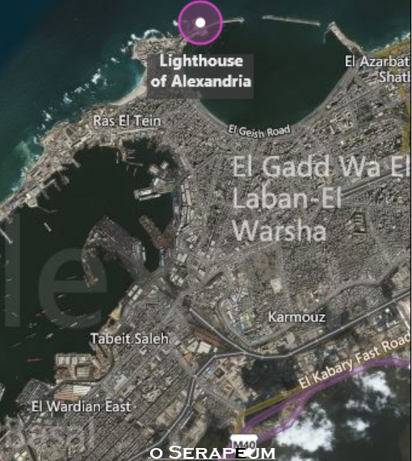

Fig. 3 Map, McKenzie, Gibson, Reyes 2004; Fig 4 Map Google; GPS coordinates: 31.28481 30.03684; 31º17'5.33" N 30º02'12.64" E

Cultural Affiliation: Hellenistic Alexandria.

Medium: Bronze

Dimensions: H 3.568 in, 90.65 mm; W 2.963 in, 75.28 mm.

Weight: 12.015 oz; 340.61952 gm

Condition: Original

Provenance: European collection, ca 1985.

Discussion: Although gradually subsumed into the all-pervading cult of Isis, Serapis was worshipped throughout the Roman world in the guise of Zeus, ruler of the heavens, or that of Hades, god of the Underworld. This small figure probably based on the model bust by Briaxis Greek sculptor, born in Athens or in Caria ca 350 BCE wears the Egyptian modius (grain measure) headdress.

References

Alvar Ezquerra, Jaime. 2008. *Romanising oriental Gods: myth, salvation, and ethics in the cults of Cybele, Isis, and Mithras*. Leiden; New York: Brill.

Chubova A.P., Kon'kova G.I., Davydova L.I. 1986. *Antichnye mastera. Skul'ptory i zhivopistsy*. Leningrad: Iskusstvo.

McKenzie, Judith S., Sheila Gibson, A. T. Reyes. 2004. “Reconstructing the Serapeum in Alexandria from the Archaeological Evidence,” *The Journal of Roman Studies*, 94: 73-121.